Joven Kaw Portfolio

Line Following Robot

This project involves using a premade robot with a forklift arm used to pick up a payload and move it around a given track.

Utilization of multiple sensor types:

* Utilizing the *sonar sensors*, the robot can drive to an object before stopping a certain distance away.
* *wheel encoders* are used to register how far the wheels have driven allowing for driving/turning a given distance/angle.
* *IR Sensors* are used to monitor the track below ensuring it stays on the right path. Utilizes a PI controller to control the rear wheels.

[GitHub Link](https://github.com/MechEng270/Portfolio/tree/489adefff047c21145d735cad558c0a9e149d1ae/Vex%20Line%20Following%20Robot)

Yahtzee

This is a recreation of the game Yahtzee featuring different opponent types:

* Amateur mode (rolls once and picks the highest option)
* Greedy mode (always rolls 3 times and tries get multiples)
* Methodical mode (will roll for their respective round type e.g., round 11 aiming for FULL HOUSE)
* Multiplayer mode (play with another human)

After each round, the scorecard is tallied for a total of 13 rounds.

[GitHub Link](https://github.com/MechEng270/Portfolio/tree/489adefff047c21145d735cad558c0a9e149d1ae/yatzhee)

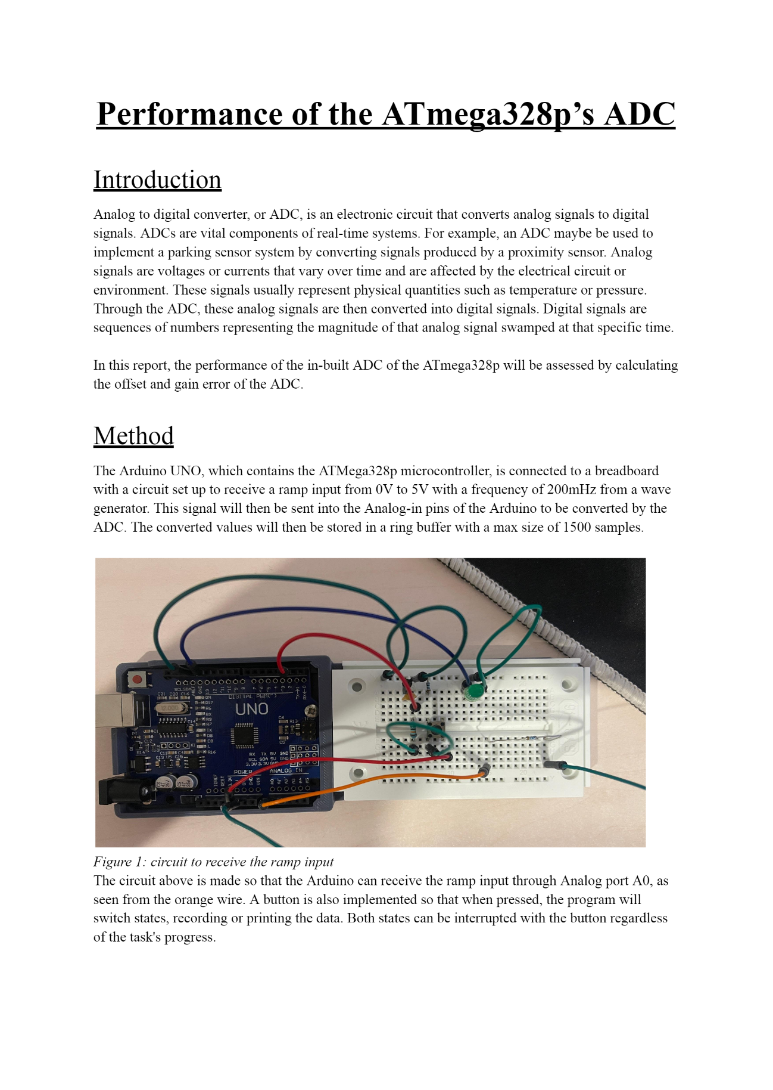ADC Arduino

This is coded onto the Arduino uno, coding in C to have high control over the ATmega328P than using the Arduino language.

* This system uses the CTC mode timer to sample the analog voltage at 200Hz.
* Sample is recorded into a buffer array, keeping track of last 7.5 seconds.
* When the button is pressed, the recorded data is printed.
* When pressed again, records data again.

[GitHub Link](https://github.com/MechEng270/Portfolio/tree/489adefff047c21145d735cad558c0a9e149d1ae/arduino%20ADC)

Microphone Chassis

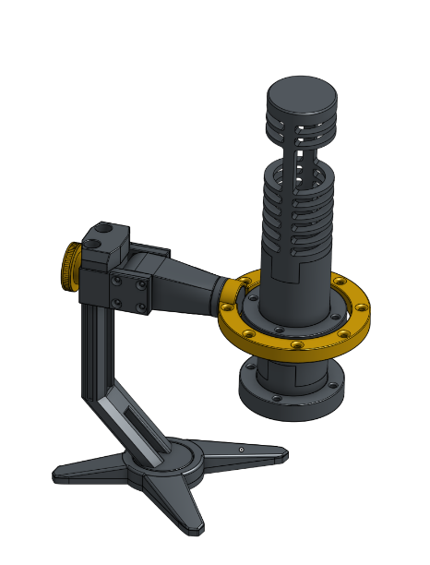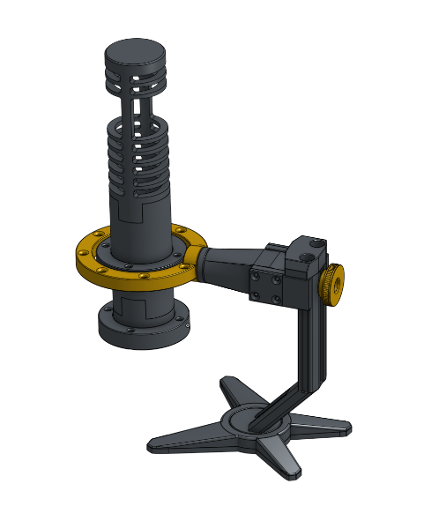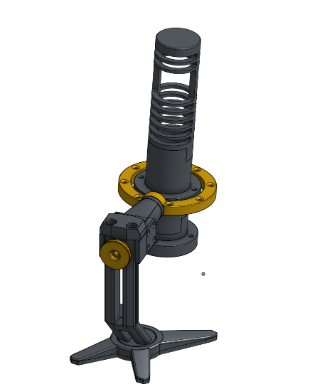

* Used CAD software to model the microphone chassis and the microphone arm/holder.
* Optimized model for Additive Manufacturing.
* Arm design has been made to be able to be universally fitted to most microphone types.
* Designed with durability in mind.